[越南雲端數據中台 / OVS-LX-VDO-01]
[越南消金新增Google Maps地理空間數據-Geocoding API]
SA / SD系統分析與設計文件

【使用說明】
- 此為「數據API」SA/SD系統分析與設計文件說明書，主要供東南亞數據團隊開發人員使用，適用範圍為 GCP Cloud Run + Fast / Flask API
- 各章節撰寫方向可參考【範例】，包含但不限於範例提供之內容，可依實際使用需求增修與調整。
文件制定／修訂履歷
制定／修訂版次 | 制定／修訂日期 | 制定／修訂說明 | 作者 | 備註
v0.1 | 2026/02/04 | 初版 | Denny
V0.2 | 2026/02/12 | 調整並完善規格 | Tom

目錄
第一章、 功能概述 (SA) 5
1.1 專案/功能說明 5
1.2 系統/服務流程 6
第二章、 API 規格 (SA) 7
2.1 基本資訊 7
2.2 上行/請求API規格 7
2.3 上行/請求API範例 7
2.4 下行/回應API規格 8
2.5 下行/回應API範例 8
2.6 處理結果代碼 9
第三章、 處理邏輯 (SA) 11
3.1 程式處理流程 11
3.2 檢核下行 12
3.3 儲存下行(GCS) 12
3.4 儲存下行(BigQuery) 13
3.5 處理結果代碼 14
第四章、 雲端資源配置與設計 (SD) 15
4.1 GCP 資源申請表 15
4.2 服務架構暨程式流程圖 15
第五章、 非功能性需求設計 (SD) 16
第六章、 附錄 17
6.1 附錄一-通訊地址發查 17
6.2 附錄二-戶籍地址發查 19
6.3 附錄三-簽約經緯度 21
6.4 附錄四-更新已發查通訊地址 23
6.5 附錄五-更新已發查戶籍地址 26
6.6 附錄六-更新已發查經緯度 29
6.7 附錄七-下行檢核程式碼 32

- 功能概述 (SA)
  - 專案/功能說明
【描述重點】
專案或功能名稱，目的及範圍說明。
- 說明 API 的設計目的、解決的問題與業務應用場景。
串接Google Maps-地理空間數據服務，做為越南消金業務後續風險分析使用，
本階段目標在於透過Google Maps API將地址轉換成經緯度定位、經緯度轉換成地址定位，進一步識別高風險、違約率偏高的用戶群所屬詳細地點，並以此作為後續驗證團夥詐欺行為的重要依據。
- 描述關聯的資料來源（例如 BigQuery、GCS、Pub/Sub）。
Google Maps-地理空間數據、BigQuery-HES、VMB用戶申貸資訊
- 指出服務是否供內部使用或對外開放。
內部使用者

  - 系統/服務流程
【描述重點】
- 系統組成與主要互動流程（可使用簡易圖或條列描述）。
- 範例：
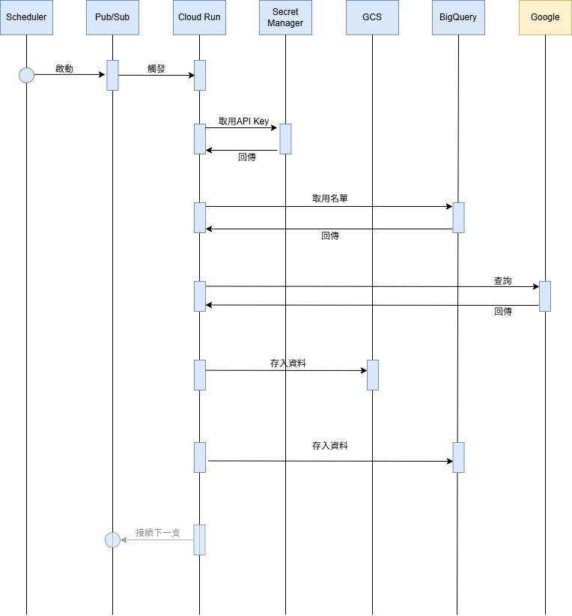

- API 規格 (SA)
  - 基本資訊
項目 | 內容
API 名稱 | Google Maps : Geocoding API
API URI | - Geocoding API :  https://maps.googleapis.com/maps/api/geocode/json?
HTTP Method | Geocoding API → GET
Content-Type | application/json
驗證方式 | API Key
功能描述 | 簡要說明 API 的主要用途與呼叫場景。  Geocoding API: 地址 ↔ 座標轉換、取得詳細地址定位
API 說明頁面 | Google說明網頁  https://developers.google.com/maps/documentation/geocoding/requests-geocoding?hl=zh-tw

  - 上行/請求API規格
LVL | 欄位名稱 | 資料型態 | 必填 | 最大長度 | 說明
 | Geocoding API |  |  |  | address 與 latlng 二擇一必填
 | Content-Type | String | N |  | 預設為 application/json
 | Api-Key | String | Y |  | Google API 金鑰
 | latlng | String | Y |  | 經緯度，"latitude,longitude"
 | address | String | Y |  | 要查詢的地址

  - 上行/請求API範例
Geocoding API
- 輸入經緯度
GET https://maps.googleapis.com/maps/api/geocode/json?latlng={latlng}&key={API_KEY}
- 輸入地址
GET https://maps.googleapis.com/maps/api/geocode/json?address={address}&key={API_KEY}
  - 下行/回應API規格

LVL | 欄位名稱 | 資料型態 | 說明
1 | place_id | string
1 | formatted_address | string
1 | types | list
1 | address_components | list
2 | long_name | string
2 | types | list
1 | geometry | dict
2 | location | dict
3 | lat | string
3 | lng | string
1 | plus_code | dict
2 | global_code | string

  - 下行/回應API範例

- Geocoding API
-- 以下僅列需求欄位
[
{
"place_id": "xxxxxxx",
"formatted_address": "xxxxx",
"types": [
"plus_code",
"postal_code",
…
],
"address_components": [
{
"long_name": "…",
"short_name": "…",
"types": [
"administrative_area_level_3",
"political"
]
},…
],
"geometry": {
"location": {
"lat": 11.111,
"lng": 121.1212
}
},
"plus_code": {
"global_code": "…"
}
}, …
]
  - 處理結果代碼
RETURNCODE | RETURNDESC | 回傳時機
Geocoding API
OK | 請求成功，回傳有效結果
ZERO_RESULTS | 查詢成功，但沒有符合的結果
OVER_QUERY_LIMIT | 已超過每日或每秒的配額限制
REQUEST_DENIED | 請求被拒絕，通常是 API Key 無效或權限不足
INVALID_REQUEST | 請求參數錯誤或缺少必要欄位
UNKNOWN_ERROR | 伺服器端錯誤，請稍後重試

- 處理邏輯 (SA)
說明業務處理邏輯，描述該API需做的事，例如：1. 檢核、2. 執行流程、3. 會使用到的DB table欄位、4. SQL語法、5. 錯誤處理、6. Log資訊留存、7. 會使用到的其它共用功能，…等
- 描述重點在於讓開發人員依循此份文件即可完成功能開發
  - 程式處理流程
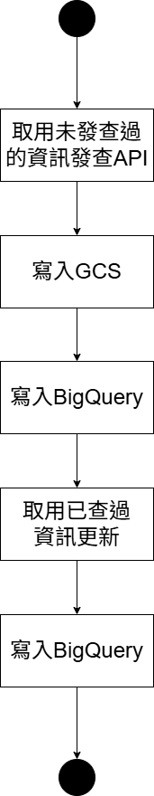
- 說明：
在執行 Geocoding API 時，判斷邏輯如下：
- 取所有客戶基本資訊：
            - HES.application.SERIAL_NUMBER；
            - HES.customer.CUID

與 客戶資訊(以下皆不能為NULL或 字串 null；每筆都取最新)：
            - 戶籍地址(RESIDENCE_ADDRESS)：
HES.customer.PERMANENT_DETAILED_ADDRESS
            - 通訊地址(CONTACT_ADDRESS)：
HES.customer.CURRENT_DETAILED_ADDRESS
            - 簽約經緯度(CONTRACT_ COORDINATES)：
VMB.apply_info.LONGITUDE / VMB.apply_info.LATITUDE

- 先取出沒有發查過的客戶(見附錄一-通訊地址發查&附錄二-戶籍地址發查&附錄三-簽約經緯度)進行發查
- 將已經發查過的資訊(見附錄四-更新已發查通訊地址&附錄五-更新已發查戶籍地址&附錄六-更新已發查經緯度)更新檢查電文資料完整性

  - 檢核下行
可參閱 附錄七-下行檢核程式碼，並依實際情形調整。
  - 儲存下行(GCS)
每個geocoding發查完的資料，儲存至：
gs://ovslxvdo01-{env}-rawdata-api/GOOGLEMAPS/GEOCODING/{data_date}_{serial_number}.json

  - 儲存下行(BigQuery)
欄位 | 資料來源 | 欄位說明
DATA_DATE | 設置BQ預設值CURRENT_DATE()
CUID | HES.customer.CUID
SERIAL_NUMBER | HES.application.SERIAL_NUMBER
CREATED_AT | HES.application.CREATED_AT
GEO_TYPE |  | 發查類型：  RESIDENCE_ADDRESS/  CONTACT_ADDRESS/  CONTRACT_ COORDINATES
REQUEST_LONGITUDE | 1) if CONTRACT_ COORDINATES:  VMB.apply_info.LONGITUDE  2) else:  NULL | 取小數點後4位
REQUEST_LATITUDE | 1) if CONTRACT_ COORDINATES:  VMB.apply_info.LATITUDE  2) else:  NULL | 取小數點後4位
REQUEST_ADDRESS | 1) if RESIDENCE_ADDRESS:  HES.customer.PERMANENT_DETAILED_ADDRESS  2) elif CONTACT_ADDRESS:  HES.customer.CURRENT_DETAILED_ADDRESS  3) else:  NULL
RESPONSE_PLACE_ID | 取下行 place_id | 取不到為NULL
RESPONSE_ADRESS | 取下行 formatted_address | 取不到為NULL
RESPONSE_GLOBAL_CODE | 取下行 plus_code.global_code | 取不到為NULL
RESPONSE_PLACE_TYPES | 取下行 types, 來源是LIST, 以逗號合併為字串 | 取不到為NULL
RESPONSE_LONGITUDE | 取下行 geometry.location.lng | 取不到為NULL
RESPONSE_LATITUDE | 取下行 geometry.location.lat | 取不到為NULL
RESPONSE_COUNTRY | 取下行 address_components, 若 address_components.types有country, 取 address_components.long_name | 取不到為NULL
RESPONSE_CITY | 取下行 address_components, 若 address_components.types有administrative_area_level_1, 取 address_components.long_name | 取不到為NULL
RESPONSE_DISTRICT | 取下行 address_components, 若 address_components.types有administrative_area_level_2, 取 address_components.long_name | 取不到為NULL
RESPONSE_WARD | 取下行 address_components, 若 address_components.types有sublocality_level_1, 取 address_components.long_name | 取不到為NULL
RESPONSE_STREET | 取下行 address_components, 若 address_components.types有route, 取 address_components.long_name | 取不到為NULL
BQ_CREATED_TIME | 設置BQ預設值CURRENT_TIMESTAMP()
BQ_UPDATED_TIME | 設置BQ預設值CURRENT_TIMESTAMP()

  - 處理結果代碼

- 雲端資源配置與設計 (SD)
具體定義系統運作所依賴的 GCP 環境參數與資源規格。
附上【GCP 資源申請表】、
  - GCP 資源申請表
// 插入檔案或附上連結
  - 服務架構暨程式流程圖
// 插入檔案或附上連結
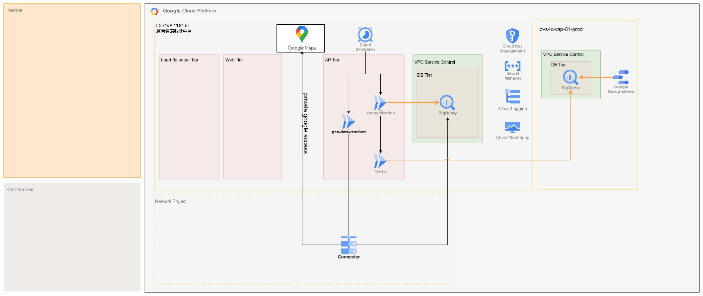

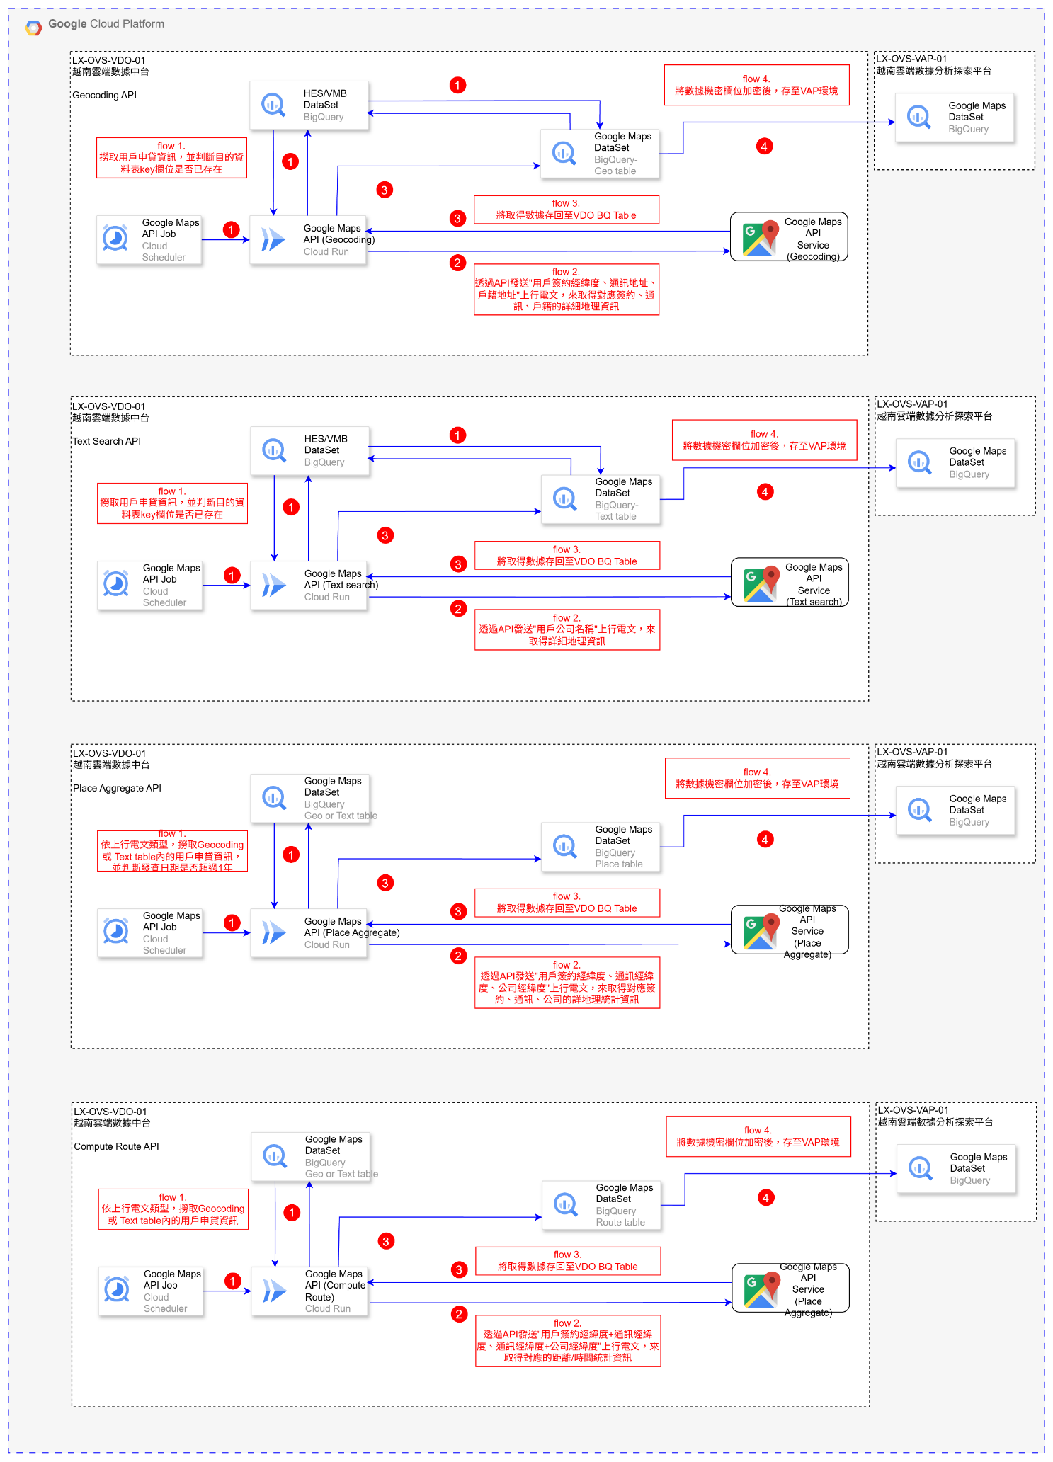
- 非功能性需求設計 (SD)
描述該API的效能、快取與錯誤處理等非功能性需求設計

- 附錄
  - 附錄一-通訊地址發查
-- 通訊地址
WITH latest_hes_application AS (
SELECT id,
serial_number,
created_at,
customer_id,
FROM `RAW_HES_DATASET.APPLICATION`
QUALIFY ROW_NUMBER() OVER (
PARTITION BY id
ORDER BY TIMESTAMP(created_at) DESC,
SAFE_CAST(finished_at AS TIMESTAMP) DESC,
PARTITION_DATE DESC
) = 1
),
latest_hes_customer AS (
SELECT id,
cuid,
current_detailed_address,
FROM `RAW_HES_DATASET.CUSTOMER`
WHERE UPPER(COALESCE(current_detailed_address, "NULL")) != "NULL"
QUALIFY ROW_NUMBER() OVER (
PARTITION BY cuid
ORDER BY BQ_UPDATED_TIME DESC
) = 1
)
SELECT appl.serial_number,
appl.created_at,
cust.cuid,
cust.current_detailed_address,
FROM latest_hes_application AS appl
JOIN latest_hes_customer AS cust ON appl.customer_id = cust.id
LEFT JOIN `RAW_EDEP_DATASET.GEOCODING` AS geo_coding ON appl.serial_number = geo_coding.serial_number
OR cust.current_detailed_address = geo_coding.REQUEST_ADDRESS
WHERE geo_coding.SERIAL_NUMBER IS NULL
AND geo_coding.REQUEST_ADDRESS IS NULL

  - 附錄二-戶籍地址發查
-- 戶籍地址
WITH latest_hes_application AS (
SELECT id,
serial_number,
created_at,
customer_id,
FROM `RAW_HES_DATASET.APPLICATION`
QUALIFY ROW_NUMBER() OVER (
PARTITION BY id
ORDER BY TIMESTAMP(created_at) DESC,
SAFE_CAST(finished_at AS TIMESTAMP) DESC,
PARTITION_DATE DESC
) = 1
),
latest_hes_customer AS (
SELECT id,
cuid,
permanent_detailed_address,
FROM `RAW_HES_DATASET.CUSTOMER`
WHERE UPPER(COALESCE(permanent_detailed_address, "NULL")) != "NULL"
QUALIFY ROW_NUMBER() OVER (
PARTITION BY cuid
ORDER BY BQ_UPDATED_TIME DESC
) = 1
)
SELECT appl.serial_number,
appl.created_at,
cust.cuid,
cust.permanent_detailed_address,
FROM latest_hes_application AS appl
JOIN latest_hes_customer AS cust ON appl.customer_id = cust.id
LEFT JOIN `RAW_EDEP_DATASET.GEOCODING` AS geo_coding ON appl.serial_number = geo_coding.serial_number
OR cust.permanent_detailed_address = geo_coding.REQUEST_ADDRESS
WHERE geo_coding.SERIAL_NUMBER IS NULL
AND geo_coding.REQUEST_ADDRESS IS NULL

  - 附錄三-簽約經緯度
-- 簽約經緯度
WITH latest_hes_application AS (
SELECT id,
serial_number,
created_at,
customer_id,
FROM `RAW_HES_DATASET.APPLICATION`
QUALIFY ROW_NUMBER() OVER (
PARTITION BY id
ORDER BY TIMESTAMP(created_at) DESC,
SAFE_CAST(finished_at AS TIMESTAMP) DESC,
PARTITION_DATE DESC
) = 1
),
latest_hes_customer AS (
SELECT id,
cuid,
FROM `RAW_HES_DATASET.CUSTOMER`
QUALIFY ROW_NUMBER() OVER (
PARTITION BY cuid
ORDER BY BQ_UPDATED_TIME DESC
) = 1
),
latest_vmb_apply_info AS (
SELECT cuid,
ROUND(longitude, 4) AS longitude,
ROUND(latitude, 4) AS latitude,
FROM `RAW_VMB_DATASET.APPLY_INFO`
WHERE UPPER(COALESCE(longitude, "NULL")) != "NULL"
AND UPPER(COALESCE(latitude, "NULL")) != "NULL"
QUALIFY ROW_NUMBER() OVER (
PARTITION BY cuid
ORDER BY BQ_UPDATED_TIME DESC
) = 1
)
SELECT appl.serial_number,
appl.created_at,
cust.cuid,
apply_info.longitude,
apply_info.latitude,
FROM latest_hes_application AS appl
JOIN latest_hes_customer AS cust ON appl.customer_id = cust.id
JOIN latest_vmb_apply_info AS apply_info ON cust.cuid = apply_info.cuid
LEFT JOIN `RAW_EDEP_DATASET.GEOCODING` AS geo_coding ON appl.serial_number = geo_coding.serial_number
OR apply_info.longitude = geo_coding.REQUEST_LONGITUDE
OR apply_info.latitude = geo_coding.REQUEST_LATITUDE
WHERE geo_coding.SERIAL_NUMBER IS NULL
AND geo_coding.REQUEST_LONGITUDE IS NULL
AND geo_coding.REQUEST_LATITUDE IS NULL

  - 附錄四-更新已發查通訊地址
-- 更新通訊地址資訊
INSERT INTO `RAW_EDEP_DATASET.GEOCODING` (
CUID,
SERIAL_NUMBER,
CREATED_AT,
GEO_TYPE,
REQUEST_ADDRESS,
RESPONSE_PLACE_ID,
RESPONSE_ADRESS,
RESPONSE_GLOBAL_CODE,
RESPONSE_PLACE_TYPES,
RESPONSE_LONGITUDE,
RESPONSE_LATITUDE,
RESPONSE_COUNTRY,
RESPONSE_CITY,
RESPONSE_DISTRICT,
RESPONSE_WARD,
RESPONSE_STREET
)
WITH latest_hes_application AS (
SELECT id,
serial_number,
created_at,
customer_id,
FROM `RAW_HES_DATASET.APPLICATION`
QUALIFY ROW_NUMBER() OVER (
PARTITION BY id
ORDER BY TIMESTAMP(created_at) DESC,
SAFE_CAST(finished_at AS TIMESTAMP) DESC,
PARTITION_DATE DESC
) = 1
),
latest_hes_customer AS (
SELECT id,
cuid,
current_detailed_address,
FROM `RAW_HES_DATASET.CUSTOMER`
WHERE UPPER(COALESCE(current_detailed_address, "NULL")) != "NULL"
QUALIFY ROW_NUMBER() OVER (
PARTITION BY cuid
ORDER BY BQ_UPDATED_TIME DESC
) = 1
),
geocoding_serial_number_list AS (
SELECT DISTINCT serial_number
FROM `RAW_EDEP_DATASET.GEOCODING`
WHERE GEO_TYPE = "CONTACT_ADDRESS"
),
distinct_adress AS (
SELECT DISTINCT REQUEST_ADDRESS,
RESPONSE_PLACE_ID,
RESPONSE_ADRESS,
RESPONSE_GLOBAL_CODE,
RESPONSE_PLACE_TYPES,
RESPONSE_LONGITUDE,
RESPONSE_LATITUDE,
RESPONSE_COUNTRY,
RESPONSE_CITY,
RESPONSE_DISTRICT,
RESPONSE_WARD,
RESPONSE_STREET,
FROM `RAW_EDEP_DATASET.GEOCODING`
WHERE GEO_TYPE = "CONTACT_ADDRESS"
AND UPPER(COALESCE(RESPONSE_ADRESS, "NULL")) IS NOT NULL
)
SELECT cust.cuid,
appl.serial_number,
appl.created_at,
"CONTACT_ADDRESS",
cust.current_detailed_address,
geo_coding.RESPONSE_PLACE_ID,
geo_coding.RESPONSE_ADRESS,
geo_coding.RESPONSE_GLOBAL_CODE,
geo_coding.RESPONSE_PLACE_TYPES,
geo_coding.RESPONSE_LONGITUDE,
geo_coding.RESPONSE_LATITUDE,
geo_coding.RESPONSE_COUNTRY,
geo_coding.RESPONSE_CITY,
geo_coding.RESPONSE_DISTRICT,
geo_coding.RESPONSE_WARD,
geo_coding.RESPONSE_STREET,
FROM latest_hes_application AS appl
JOIN latest_hes_customer AS cust ON appl.customer_id = cust.id
LEFT JOIN geocoding_serial_number_list AS ser_list ON appl.serial_number = ser_list.serial_number
LEFT JOIN distinct_adress AS geo_coding ON cust.current_detailed_address = geo_coding.REQUEST_ADDRESS
WHERE ser_list.serial_number IS NULL
AND geo_coding.REQUEST_ADDRESS IS NOT NULL

  - 附錄五-更新已發查戶籍地址
-- 更新戶籍地址資訊
INSERT INTO `RAW_EDEP_DATASET.GEOCODING` (
CUID,
SERIAL_NUMBER,
CREATED_AT,
GEO_TYPE,
REQUEST_ADDRESS,
RESPONSE_PLACE_ID,
RESPONSE_ADRESS,
RESPONSE_GLOBAL_CODE,
RESPONSE_PLACE_TYPES,
RESPONSE_LONGITUDE,
RESPONSE_LATITUDE,
RESPONSE_COUNTRY,
RESPONSE_CITY,
RESPONSE_DISTRICT,
RESPONSE_WARD,
RESPONSE_STREET
)
WITH latest_hes_application AS (
SELECT id,
serial_number,
created_at,
customer_id,
FROM `RAW_HES_DATASET.APPLICATION`
QUALIFY ROW_NUMBER() OVER (
PARTITION BY id
ORDER BY TIMESTAMP(created_at) DESC,
SAFE_CAST(finished_at AS TIMESTAMP) DESC,
PARTITION_DATE DESC
) = 1
),
latest_hes_customer AS (
SELECT id,
cuid,
permanent_detailed_address,
FROM `RAW_HES_DATASET.CUSTOMER`
WHERE UPPER(COALESCE(permanent_detailed_address, "NULL")) != "NULL"
QUALIFY ROW_NUMBER() OVER (
PARTITION BY cuid
ORDER BY BQ_UPDATED_TIME DESC
) = 1
),
geocoding_serial_number_list AS (
SELECT DISTINCT serial_number
FROM `RAW_EDEP_DATASET.GEOCODING`
WHERE GEO_TYPE = "RESIDENCE_ADDRESS"
),
distinct_adress AS (
SELECT DISTINCT REQUEST_ADDRESS,
RESPONSE_PLACE_ID,
RESPONSE_ADRESS,
RESPONSE_GLOBAL_CODE,
RESPONSE_PLACE_TYPES,
RESPONSE_LONGITUDE,
RESPONSE_LATITUDE,
RESPONSE_COUNTRY,
RESPONSE_CITY,
RESPONSE_DISTRICT,
RESPONSE_WARD,
RESPONSE_STREET,
FROM `RAW_EDEP_DATASET.GEOCODING`
WHERE GEO_TYPE = "RESIDENCE_ADDRESS"
AND UPPER(COALESCE(RESPONSE_ADRESS, "NULL")) IS NOT NULL
)
SELECT cust.cuid,
appl.serial_number,
appl.created_at,
"RESIDENCE_ADDRESS",
cust.permanent_detailed_address,
geo_coding.RESPONSE_PLACE_ID,
geo_coding.RESPONSE_ADRESS,
geo_coding.RESPONSE_GLOBAL_CODE,
geo_coding.RESPONSE_PLACE_TYPES,
geo_coding.RESPONSE_LONGITUDE,
geo_coding.RESPONSE_LATITUDE,
geo_coding.RESPONSE_COUNTRY,
geo_coding.RESPONSE_CITY,
geo_coding.RESPONSE_DISTRICT,
geo_coding.RESPONSE_WARD,
geo_coding.RESPONSE_STREET,
FROM latest_hes_application AS appl
JOIN latest_hes_customer AS cust ON appl.customer_id = cust.id
LEFT JOIN geocoding_serial_number_list AS ser_list ON appl.serial_number = ser_list.serial_number
LEFT JOIN distinct_adress AS geo_coding ON cust.permanent_detailed_address = geo_coding.REQUEST_ADDRESS
WHERE ser_list.serial_number IS NULL
AND geo_coding.REQUEST_ADDRESS IS NOT NULL

  - 附錄六-更新已發查經緯度
-- 更新簽約經緯度
INSERT INTO `RAW_EDEP_DATASET.GEOCODING` (
CUID,
SERIAL_NUMBER,
CREATED_AT,
GEO_TYPE,
REQUEST_LONGITUDE,
REQUEST_LATITUDE,
RESPONSE_PLACE_ID,
RESPONSE_ADRESS,
RESPONSE_GLOBAL_CODE,
RESPONSE_PLACE_TYPES,
RESPONSE_LONGITUDE,
RESPONSE_LATITUDE,
RESPONSE_COUNTRY,
RESPONSE_CITY,
RESPONSE_DISTRICT,
RESPONSE_WARD,
RESPONSE_STREET
)
WITH latest_hes_application AS (
SELECT id,
serial_number,
created_at,
customer_id,
DATE(TIMESTAMP(created_at)) AS data_date
FROM `RAW_HES_DATASET.APPLICATION`
QUALIFY ROW_NUMBER() OVER (
PARTITION BY id
ORDER BY TIMESTAMP(created_at) DESC,
SAFE_CAST(finished_at AS TIMESTAMP) DESC,
PARTITION_DATE DESC
) = 1
),
latest_hes_customer AS (
SELECT id,
cuid,
FROM `RAW_HES_DATASET.CUSTOMER`
WHERE UPPER(COALESCE(current_detailed_address, "NULL")) != "NULL"
QUALIFY ROW_NUMBER() OVER (
PARTITION BY cuid
ORDER BY BQ_UPDATED_TIME DESC
) = 1
),
latest_vmb_apply_info AS (
SELECT cuid,
ROUND(longitude, 4) AS longitude,
ROUND(latitude, 4) AS latitude,
FROM `RAW_VMB_DATASET.APPLY_INFO`
WHERE UPPER(COALESCE(longitude, "NULL")) != "NULL"
AND UPPER(COALESCE(latitude, "NULL")) != "NULL"
QUALIFY ROW_NUMBER() OVER (
PARTITION BY cuid
ORDER BY BQ_UPDATED_TIME DESC
) = 1
),
geocoding_serial_number_list AS (
SELECT DISTINCT serial_number
FROM `RAW_EDEP_DATASET.GEOCODING`
WHERE GEO_TYPE = "CONTRACT_COORDINATES"
),
distinct_coordinates AS (
SELECT DISTINCT REQUEST_LONGITUDE,
REQUEST_LATITUDE,
RESPONSE_PLACE_ID,
RESPONSE_ADRESS,
RESPONSE_GLOBAL_CODE,
RESPONSE_PLACE_TYPES,
RESPONSE_LONGITUDE,
RESPONSE_LATITUDE,
RESPONSE_COUNTRY,
RESPONSE_CITY,
RESPONSE_DISTRICT,
RESPONSE_WARD,
RESPONSE_STREET,
FROM `RAW_EDEP_DATASET.GEOCODING`
WHERE GEO_TYPE = "CONTRACT_COORDINATES"
AND UPPER(COALESCE(REQUEST_LONGITUDE, "NULL")) IS NOT NULL
AND UPPER(COALESCE(REQUEST_LATITUDE, "NULL")) IS NOT NULL
)
SELECT cust.cuid,
appl.serial_number,
appl.created_at,
"CONTRACT_COORDINATES",
apply_info.longitude,
apply_info.latitude,
geo_coding.RESPONSE_PLACE_ID,
geo_coding.RESPONSE_ADRESS,
geo_coding.RESPONSE_GLOBAL_CODE,
geo_coding.RESPONSE_PLACE_TYPES,
geo_coding.RESPONSE_LONGITUDE,
geo_coding.RESPONSE_LATITUDE,
geo_coding.RESPONSE_COUNTRY,
geo_coding.RESPONSE_CITY,
geo_coding.RESPONSE_DISTRICT,
geo_coding.RESPONSE_WARD,
geo_coding.RESPONSE_STREET,
FROM latest_hes_application AS appl
JOIN latest_hes_customer AS cust ON appl.customer_id = cust.id
JOIN latest_vmb_apply_info AS apply_info ON cust.cuid = apply_info.cuid
LEFT JOIN geocoding_serial_number_list AS ser_list ON appl.serial_number = ser_list.serial_number
LEFT JOIN distinct_coordinates AS geo_coding ON apply_info.longitude = geo_coding.REQUEST_LONGITUDE
AND apply_info.latitude = geo_coding.REQUEST_LATITUDE
WHERE ser_list.serial_number IS NULL
AND geo_coding.REQUEST_LONGITUDE IS NOT NULL
AND geo_coding.REQUEST_LATITUDE IS NOT NULL

  - 附錄七-下行檢核程式碼
from typing import List, Optional
from pydantic import BaseModel, Field, RootModel

class AddressComponent(BaseModel):
long_name: Optional[str] = None
short_name: Optional[str] = None
types: Optional[List[str]] = None

class Location(BaseModel):
lat: Optional[float] = None
lng: Optional[float] = None

class Viewport(BaseModel):
northeast: Optional[Location] = None
southwest: Optional[Location] = None

class Geometry(BaseModel):
location: Optional[Location] = None
location_type: Optional[str] = None
bounds: Optional[Viewport] = None
viewport: Optional[Viewport] = None

class NavigationLocation(BaseModel):
latitude: Optional[float] = None
longitude: Optional[float] = None

class NavigationPoint(BaseModel):
location: Optional[NavigationLocation] = None
restricted_travel_modes: Optional[List[str]] = Field(None, alias='restricted_travel_modes')

class PlusCode(BaseModel):
compound_code: Optional[str] = None
global_code: Optional[str] = None

class GeocodeResult(BaseModel):
address_components: Optional[List[AddressComponent]] = None
formatted_address: Optional[str] = None
geometry: Optional[Geometry] = None
navigation_points: Optional[List[NavigationPoint]] = None
place_id: Optional[str] = None
plus_code: Optional[PlusCode] = None
types: Optional[List[str]] = None

class GeocodeResponse(RootModel[List[GeocodeResult]]):
pass

